**Set up Development Environment**

**Module Description**

Developing starts with a Development Environment. In this module, you will be installing the tools, code and database applications on your workstations.

**Scenario**

After discussing the detailed design, you will go back to your desk and set up an individual development environment. This includes installing the development tools, a local copy of the database, and accessing the code repository.

**ADM Activity Context Diagram**

* Technical Architecture > 4300 Build Technical Architecture > 4305 Build and Test Application Architecture
* Technical Architecture > 4300 Build Technical Architecture > 4315 Build and Test Development Architecture

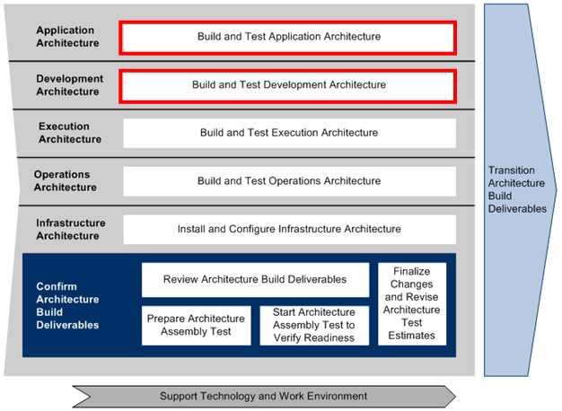

**Roles**

|  |  |  |  |
| --- | --- | --- | --- |
| **Role** | **ADM Task** | **ADM Responsibility** | **Description** |
| Team (All) | 4305 - Build and Test Application Architecture  4315 - Build and Test Development Architecture | Primary Performer | Set up development environment to begin working on application build activities. |

**Participant Instructions**

1. Launch the [Tools Primer](https://accenture.desire2learn.com/content/enforced/9406-Pending/Tools%20Primer/ADF_2_0_Tools_Primer.docx?_&d2lSessionVal=YnoL4daZGC8ne2RyGf0cWMrk8) and display the section ‘**Working with Subclipse client’** (as a reference).

2. Follow the directions and perform the actions of the faculty as they demonstrate: adding the Subversion Repository Location, getting a copy of the Release 1 Festival Portal Codebase, and saving/committing code changes.

3. For future reference, document the URL, username, and password used to connect to the Release 1 code repository in the Subversion Server.

4. Once complete, you should have confirmed your access to the codebase by opening your Project Explorer tab, viewing the Festival Portal project folders, and viewing the java code in the src (Source) folder.

5. Ensure that all the libraries are set up in your copy of the Festival Portal codebase. The following is a list (visible from Project Explorer):

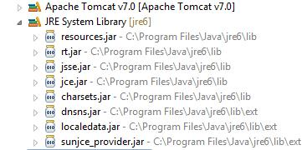

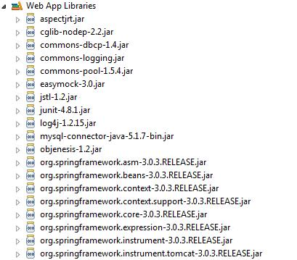

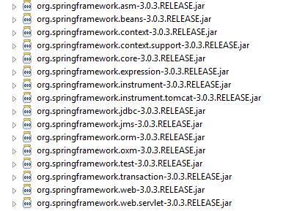

6. If the libraries are not in your copy of the Festival Portal codebase, then follow the steps in the Environment Setup Instructions to add the appropriate libraries.

7. Copy the SQL Script from the [Physical Database Design](https://accenture.desire2learn.com/content/enforced/9406-Pending/NCCC_Project_Work_Products/3c_App_Build/Release_1/PhysDataDes_FERS_R1_REF.docx?_&d2lSessionVal=YnoL4daZGC8ne2RyGf0cWMrk8) document to build the physical database model and populate some sample data.

a. Run the script in the MySQL database system you created previously.

b. Confirm that the database system is setup correctly by:

i. Confirming that no errors were generated by the script execution

ii. Executing the following SQL query: SELECT * FROM EVENT you should return 3 records with event names: ‘Rose Parade’, ‘NCCL Cricket League’ and ‘Fireworks Show’. See the screenshot below:

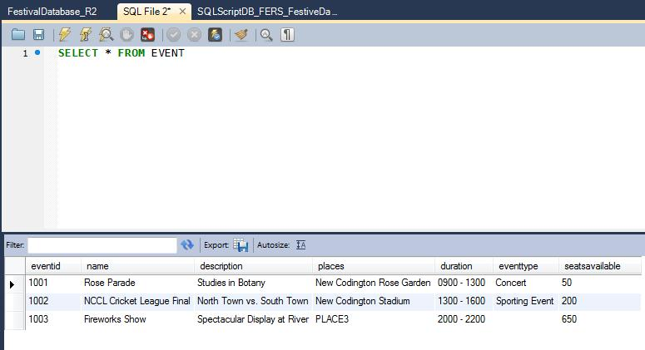

8. Congratulations, you are all set up!

**Hints and Tips**

1. Notify a team member, Team Lead or Team Manager, as appropriate, if you receive messages that were not shown in the demonstration.

2. Incorrect installation of tools may impact your ability to complete future activities in a timely manner.

3. No other documents (e.g. Office documents) should be added to the Subversion code repository except when instructed to do so. Doing so will run this risk of you being unable to check-in your code files!